Chapter 7 Learning

What is learning?

**Learning**: the process of acquiring new and relatively enduring information or behaviors

* This acquisition is the result of experience
* Learning can involve both beneficial and negative behaviors
* We learn in order to adapt to our environment

**Associative learning**: learning that certain events occur together

* Associations between stimuli (classical conditioning);
* Associations between actions and their consequences (operant conditioning)
* Associations between other’s actions and their consequences (learning by observation, modeling)

**Behaviorism**:

Beginning 20th century

First big paradigm of psychology

Rejection of the introspective method

(introspection has way too much subjectivity)

Psychology:

1. Should be an objective science, that
2. Studies behavior without reference to mental processes

Today, most psychologists agree with (1) but not with (2)

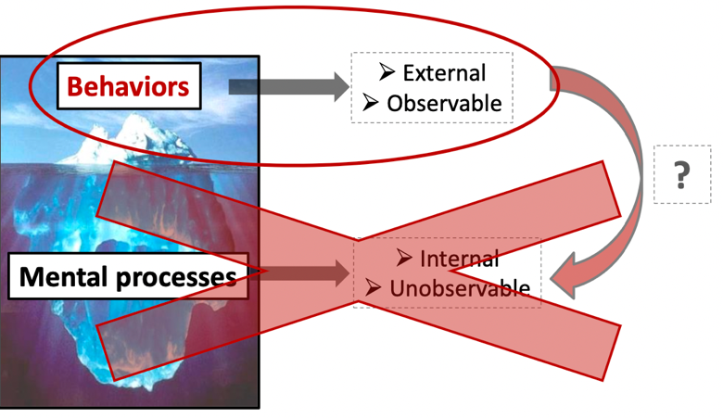

Stimuli => behaviors => consequences

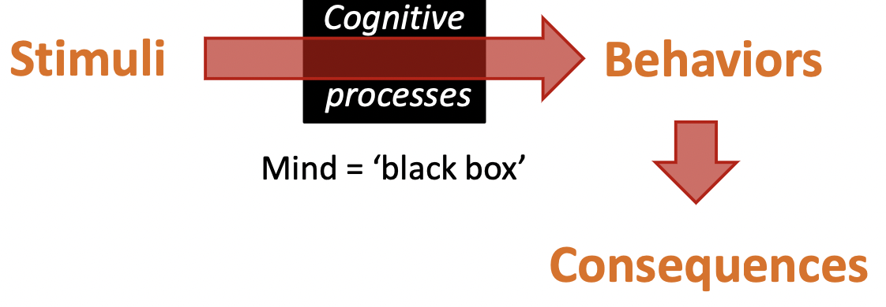

Cognitive illusion

**No reference to internal mental states**

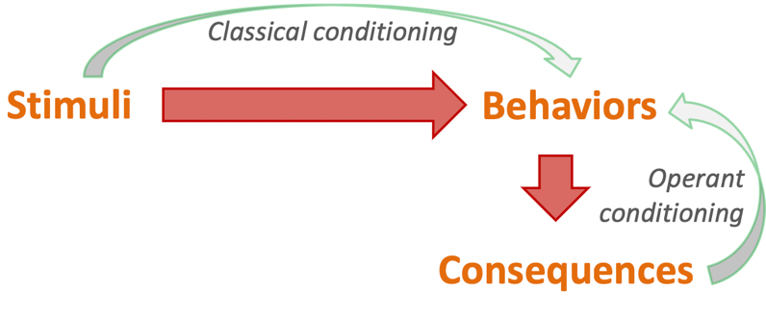

Regarding the historical context in which conditioning has been identified, it is crucial to keep in mind that **conditioning is limited** and should always be **put in perspective with its impacts on the subject’s cognition**.

**Classical conditioning**

**(Relies on automatic reactions)**

A type of learning in which we link 2(or more) stimuli

**Russian physiologist: Ivan Pavlov**

**Pavlov dog experiment**

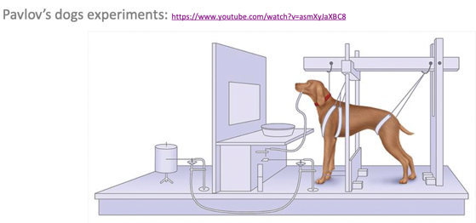

Actually, the dog salivates when it sees the experimenter coming in.

Conclusion:

**A physical response can be produced solely by way of a mental association**

Stimulus: metronome, light turning on and off…

Dog: associating food with stimulus

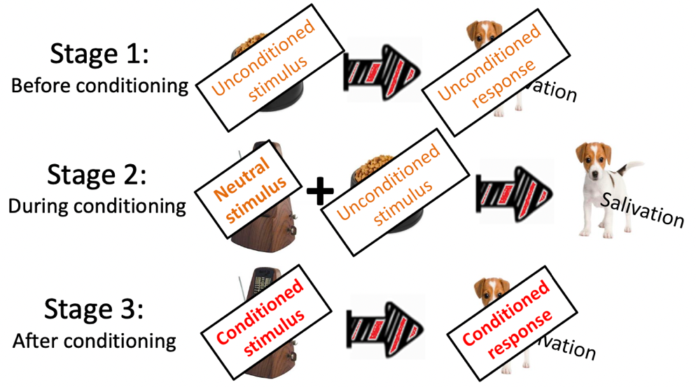

After certain levels of repetition, neutral stimulus becomes conditioned stimulus. As soon as the dog hears the sound of metronome, it salivates.

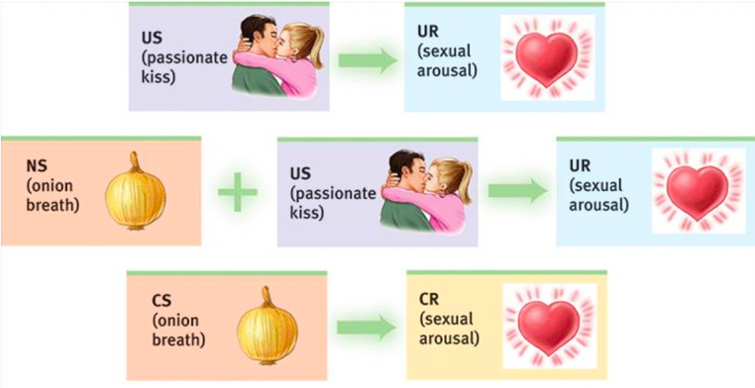

**Pavlov’s legacy**

Classical conditioning is one way that virtually all organisms learning to adapt to their environment.

* Animal training, education, therapies, advertisement…

Example: you’ve once had bad food (US) and you had nausea (UR) against that food later.

If you’re familiar with the smell (NS) of bad food (US) every time you have it, the smell itself can give you nausea later on.

Pavlov showed how a process such as learning can be studies objectively => his method involved no subjective judgements or guesses about what went on in a dog’s mind

**John B. Watson**

**Little Albert experiment**

US: hammer banged on a metal bar

UR: fear

NS: white rat, bunny, dog, rabbit, Santa Claus mask (fluffy, cute things)

Let little albert associate fear with neural stimulus

The experiment is considered unethical by today’s standards.

**Emotional responses can be acquired through classical conditioning**.

**PTSD**: some symptoms are **developed and maintained** through classical conditioning. The traumatic event may act as an unconditioned stimulus that elicits an unconditioned response characterized by extreme fear and anxiety.

Sometimes the stimulus is so strong that it associates the unconditioned stimulus and unconditioned responses in one time, no need for repetition.

(NS) DOG + (US) being bitten = (UR) extreme fear

**Counterconditioning**: behavior therapy procedures that use classical conditioning to evoke new responses to stimuli that are triggering unwanted behaviors

* **Exposure therapies**: behavioral techniques that treat anxieties by exposing people (in imaginary or actual situations) to the things they fear and avoid.

**Gradually exposed** to the things you’re afraid of

* **Systematic desensitization**: a treatment for phobias in which the individual is trained to relax while being exposed to progressively more anxiety-provoking stimuli
* **Virtual reality exposure therapy**

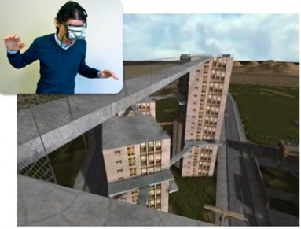

* **Aversion therapy**: a type of behavior therapy designed to encourage individuals to give up undesirable habits by causing them to associate the habit with an unpleasant effect.

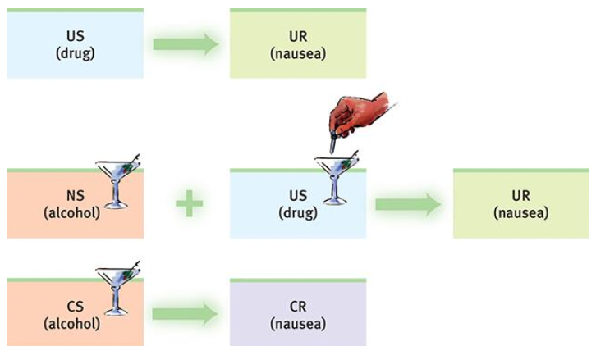

Problem: subjects are aware that it is the drug, not the alcohol, that cause the nausea

**Biological limits and cognition’s influence on classical conditioning**

In their dismissal of “mentalistic” concepts (such as consciousness), Pavlov and Watson underestimated the importance of **biological constraints** and the effects of **cognitive processes** (thoughts, perceptions, expectations)

An animal’s capacity for conditioning is limited by biological constraints

* Each species’ predispositions prepare it to learn the associations that enhance its survival

**Preparedness**: a biological predisposition to learn associations that **have survival value** (such as between taste and nausea)

Effects of radiation on laboratory animals

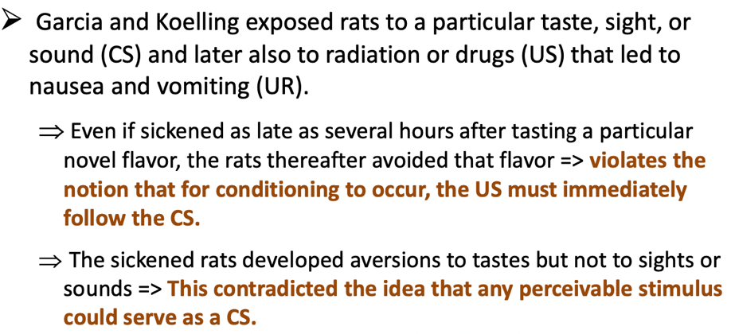

Biology prepares us to learn **taste aversions** to toxic foods.

Conclusion from Garcia’s experiments:

**Natural selection favors traits that aid survival**

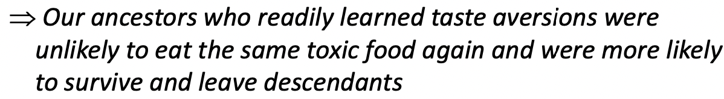

**Preparedness is adaptive**

**Cognition’s influence** on classical conditioning

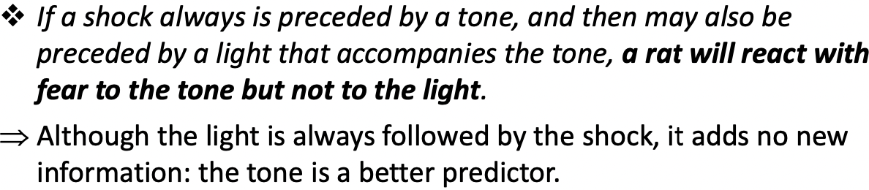

You’ll be conditioned to be afraid to the tone, but not to the light.

**The more predictable the association, the stronger the conditioned response: animals learn expectancy.**

* Awareness of how likely it is that the US will occur

Awareness that a reaction is caused by a stimulus but not another weakens the association between the two stimuli

(eg: alcohol, nausea-provoking drug and feeling sick)

**Conditioned likes and dislikes are even stronger when people notice and are aware of the associations they have learned.**

Exercise:

It is springtime and the pollen from the flowers causes you to sneeze. Soon you are sneezing at the mere sight of a flower, real or fake.

US: Pollen

UR: Sneezing

NS: flower

Conditioned Stimulus: Flower

Conditioned response: Sneezing

Associating Pollen and Flower

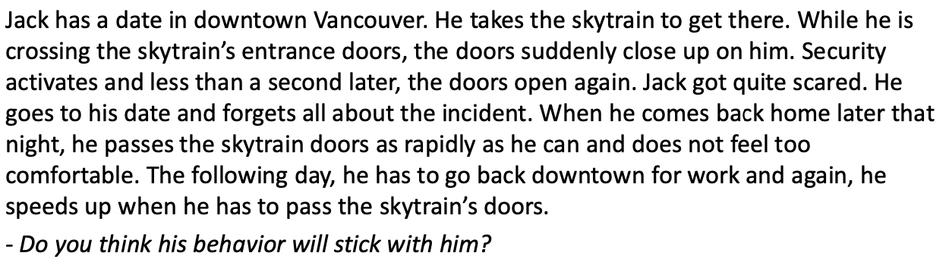

US: Skytrain’s door closing up while he passes through

UR: Fear; Speed up to pass

NS: skytrain’s door closing

CS: skytrain’s door closing

CR: Fear; Speed up to pass

The behavior won’t stick with him, because we need to account for the cognition. Depends on the frequency of having this experience.

Example2:

Anna loves Coca-Cola and drinks some quite often when she is thirsty. One day, while she is walking in the street, he notices a vending machine displaying a huge ad for Coca-Cola. She suddenly realized how thirty she is and buys a can. Can conditioning explain her purchase? If so, give details.

US: Being thirsty

UR: drinking Coca-Cola

NS: seeing the Logo of Coca-Cola

CS: seeing the Logo of Coca-Cola

CR: drinking Coca-Cola

How can attachment be explained by classical conditioning?

Operant Conditioning

A type of learning in which a behavior becomes more likely to recur if followed by a reinforcer or less likely to recur if followed by a punisher

Psychologist: B.F. Skinner

Law of effect:

Thorndike’s principle that behaviors followed by favorable consequences become more likely,

And that behaviors followed by unfavorable consequences become less likely

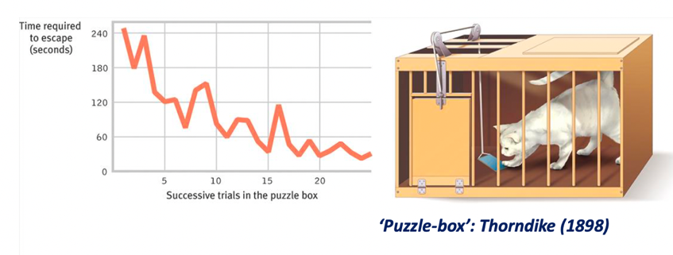

Learning through trials and errors; if there’s incentives outside, the processes become easier

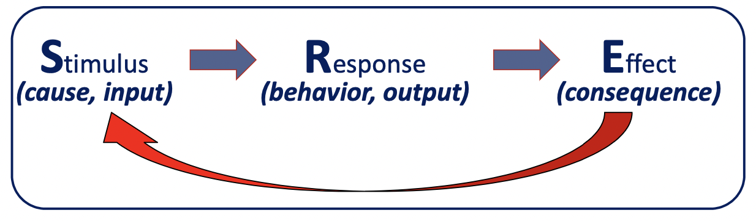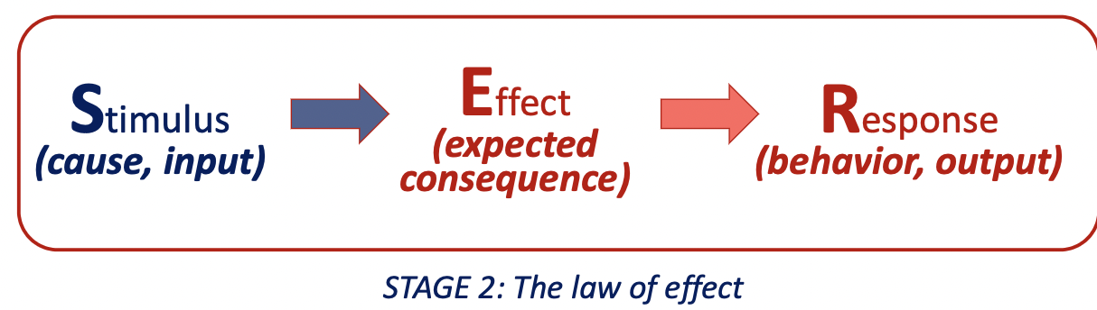

We learn to expect consequences

A behavior changes because its consequences

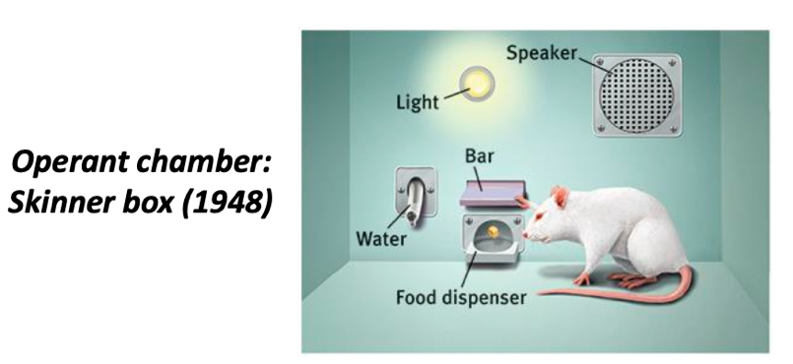

Operant chamber:

A chamber (aka Skinner’s box) containing a bar or key that an animal can manipulate to obtain a food or water reinforcer;

Attached devices record the animal’s rate of bar pressing or key pecking

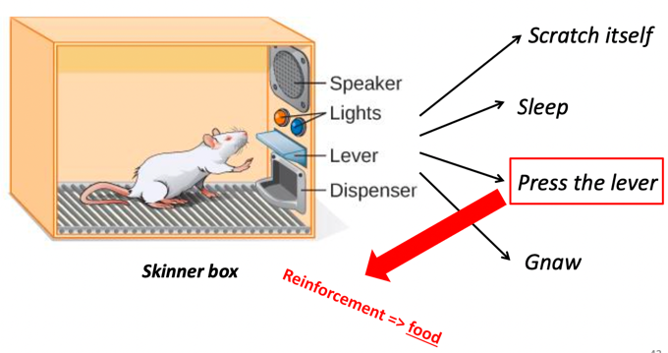

**Reinforcement increases a behavior**

Every time the rat presses the lever, the food becomes present.

Knowing what action can lead to this consequence, the rat has the behavior of pressing the lever more and more frequent

**Punishment decreases a behavior**

If the rat gnaw, there’ll be loud sound.

The rat gnaws less frequently

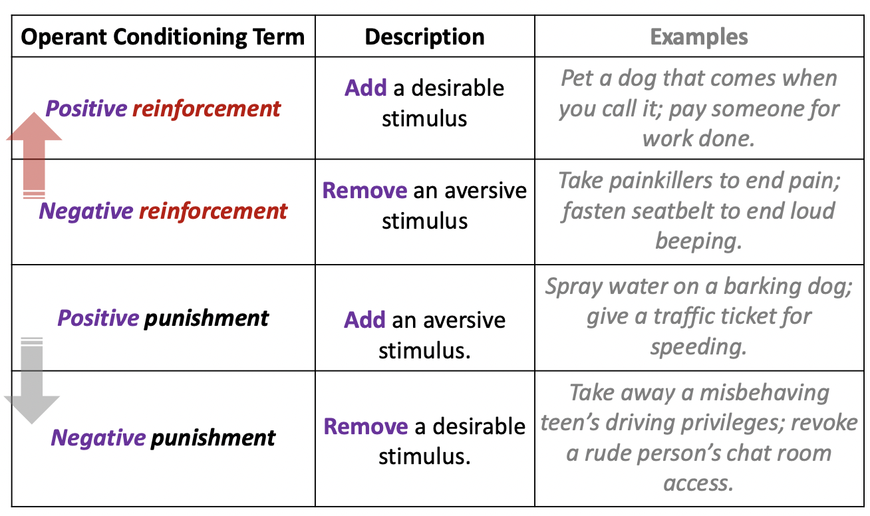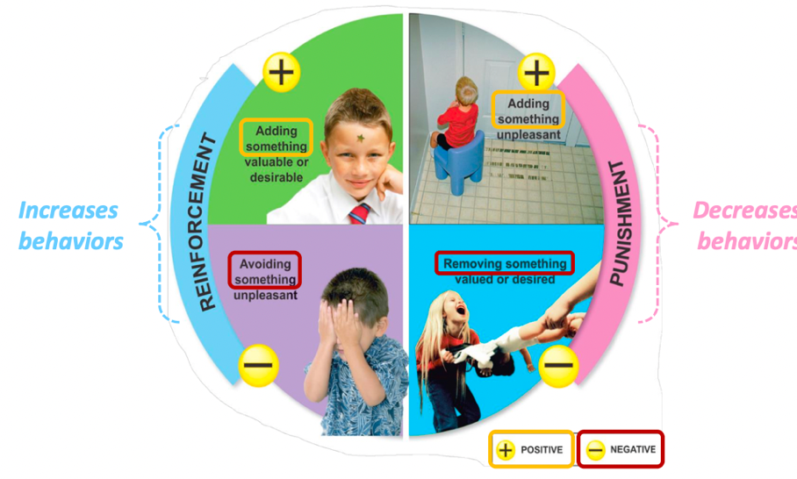

Positive punishment (adding something)

**Shaping**:

An operant conditioning procedure in which reinforcers guide behavior toward closer and closer approximations of the desired behavior

* Used to train animals

Reinforcing successful approximations.

Shaping can help us understand **what nonverbal organisms perceive**:

If we can shape an organism to respond to one stimulus and not to another, then we know they can perceive the difference

If animals can perceive the difference between facial appearance, that means they can perceive human faces.

**Discriminative stimuli**: signal that a response will be reinforced

For example, if you say “treat” and the dog instantly roll his body,

Then “treat” is the discriminative stimuli

**We continually reinforce and shape others’ behaviors we don’t want to reinforce**

If you cry in the middle of the night and ends up in your parents’ bed

Parents’ behavior is negative reinforcement.

Stimuli removed: child cried

**Reinforcers vary with circumstances**

What is reinforcing to one animal/circumstance may not be to another

**Primary reinforcer**:

An innately reinforcing stimulus, such as one that satisfies a **biological need**

Primary reinforcers are unlearned.

So you trained animals with food as the stimuli

**Secondary reinforcer**:

A stimulus that gains its reinforcing power through its association with a primary reinforcer

Clicker is the secondary reinforcer

* Learned associations with primary reinforcers

**Delayed reinforcers**:

Presented after a delayed interval following the desired behavior

Only humans respond to delayed reinforcers

Ex: we get paycheck at the end of the week

To function effectively, we must learn to **delay gratification** (self-control)

Enjoyment of playing now as opposed to doing well in the test tomorrow

**The Marshmallow experiment**: being able to delay gratification leads to better outcomes.

You ask the kids to not eat marshmallow in 15 minutes, and tell them if they do that, they’ll get a second one.

Having delay gratification has association with having better outcomes in life

**Correlation is not equals to causation**

There are cofounding variables: kids with wealthy background

**Continuous reinforcement schedule**:

Reinforcing the desired response **every time** it occurs

* Learning occurs rapidly
* But extinction occurs rapidly too

**Partial (intermittent) reinforcement schedules**:

Reinforcing a response only part of the time

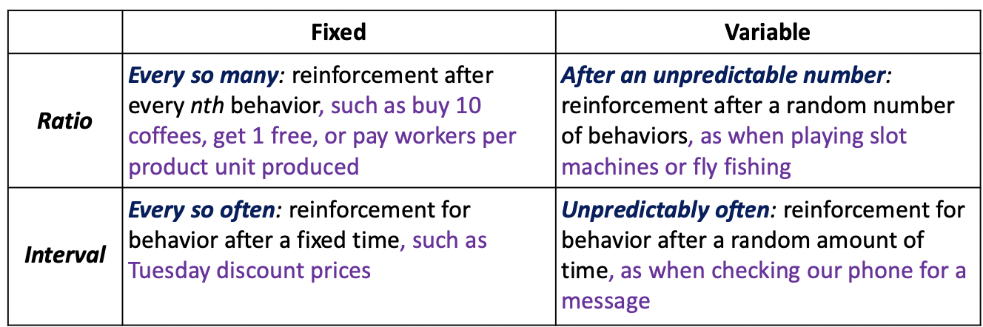

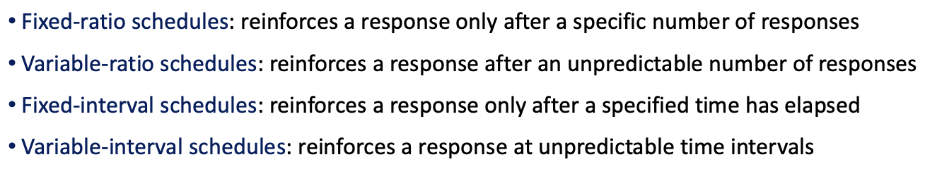

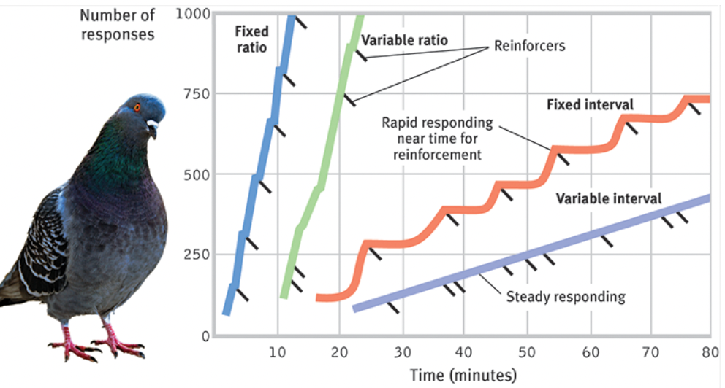

Variable-interval schedules is the best to reinforce a behavior

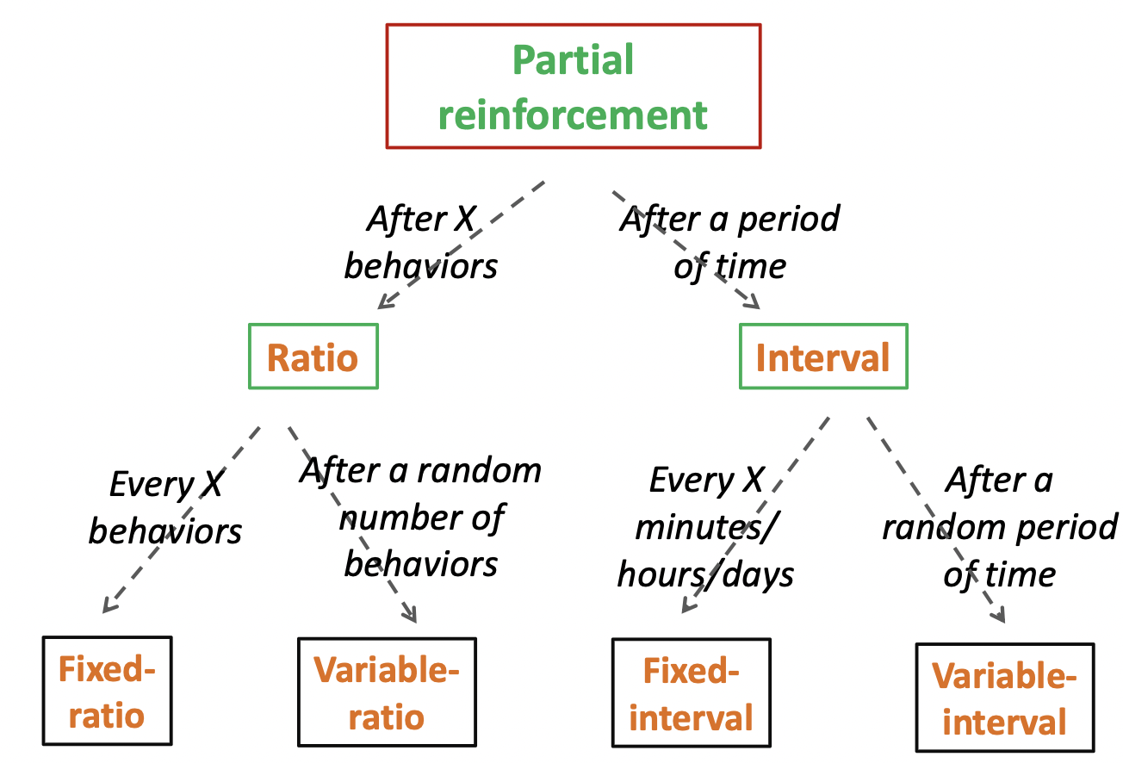

People gamble because the schedule of the reinforcement

Application of Operant conditioning:

**At school**: immediate, personalized feedback

For Learning Curve, you won’t get the credits of the question until you get it right

**In sports**: gradually increasing challenges

**At work**: define and reward specific, achievable performance

**In parenting**: do your best not to cave to whims. Explain why bad behaviors have bad consequences. Target a specific behavior, reward it, and watch it increase

**To change your own behavior**

* State a realistic goal in measurable terms and announce it
* Decide how, when, and where you will work toward your goal (plan for the goal)
* Monitor how often you engage in your desired behavior
* Reinforce the desired behavior (when you’ve been having good behavior, reward yourself)
* Reduce the rewards gradually

Learned associations feed our habitual behaviors

* Some behaviors become linked with the context
* Our next experience of that context will evoke our habitual response

**Forming “benefit habits” take on average 66 days.**

Habit regarding to workouts takes longer than that

Critics of Operant Conditioning

Drawbacks of physical punishment

* Punished behavior is suppressed, but not forgotten. It only leads to a **temporary state**
* Punishment teaches discrimination among situations

(kids know they can’t scream around the house, but how about screaming elsewhere)

* Punishment can teach fear

A punished child may associate fear not only with the undesirable behavior but also with the person who delivered the punishment or where it occurred

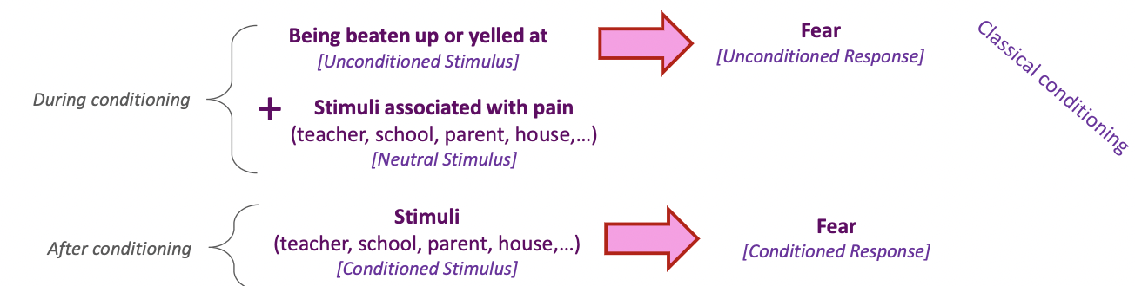

* Physical punishment may increase aggression by modeling violence as a way to cope with problems

= many aggressive parents come from abusive families

Generally, physical punishment is linked with neural and psychological negative outcomes

Correlation is not equals to causation

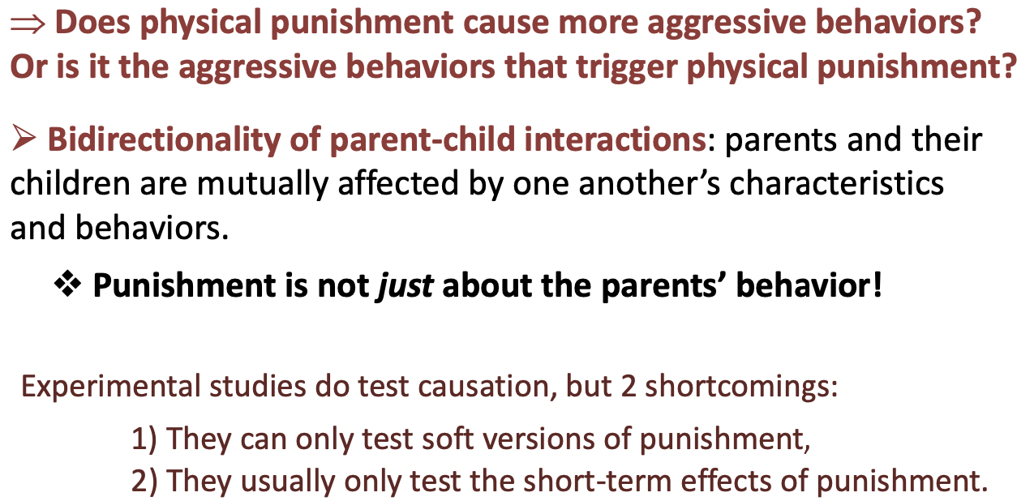

Punishment still provokes fear in the times when it does.

Changing punishment into negative reinforcement (remove a negative stimuli)

“you clean up your room this minute or no dinner”

You’re welcome to the dinner once you get the room cleaned up

Removing the negative stimuli, in this case, it’s the state of “no dinner”

“If you don’t get your homework, there’ll be no car”

You might get a car once you get your homework done

Drawbacks for giving kids rewards

* If a kid is sensitive to the point of having his love for school destroyed because he missed recess, how will he deal with real though consequences that are part of life?
* Rewards for good behavior cannot keep pace with children’s changing desires
* In real life, citizens are not rewarded extrinsically for being good citizens

( you don’t get a bonus check for being good citizens

Instead of “punishment”, we can think about “consequences”

How about teaching kids that virtue is its own reward and bad actions have bad consequences

We most easily learn and retain behaviors that reflect our biological predispositions.

* You can’t use electric shock to avoid pigeons to not to peck

**Instinctive drift**:

The tendency of learned behaviors to gradually revert to biologically predisposed patterns

**Cognitive map**:

A mental representation of the layout of one’s environment

Eg: after exploring a maze, rats act as if they have learned a cognitive map of it

**Latent learning:**

Learning that occurs but is not apparent until there is an incentive to demonstrative it.

When kids do something to gain a reward, they lose the inherent drive to do this thing.

**Extrinsic motivation**:

A desire to perform a behavior to receive promised rewards or avoid threatened punishment

**Intrinsic motivation**:

A desire to perform a behavior effectively for its own sake

Play is the true model of learning

Outside incentives can divide attention and reduce performances when it comes to complex tasks

Rewards may cancel out our natural sense of play

Discipline without Conditioning

**Discipline**: set of strategies and behaviors used to teach children how to behave appropriately

**Internalization**: process by which children learn and accept the reasons for desired behavior => effective discipline

**Indigenous approaches**

Discipline is part of learning

How to behave in the society and in the environment

Ethics of non-interference:

When child ask a question to the elder, elder explains by telling a story

Story telling

* Gives individuals the freedom to explore and learn through trial and error
* It allows children to learn by experiencing natural consequences
* It fosters independent thinking

=> children become self-reliant by knowing how to survive and coexist with others in their environment

Inductive discipline:

Shows the individual how their actions impact others

* As a result of bad behavior, the child would endure discipline through **teasing, laughter, or ignoring**
* Children are given **moral values** not to lie, cheat, or steal from their community

Restorative justice:

* Restorative justice recognizes wrongdoing as impacting relationships.

It therefore seeks to **restore balance in the community** after a wrong has occurred

As opposed to being focused on a punishment, this process forces offenders to be accountable to those they have hurt

First Nations’ principles of learning:

Belong, Mastery, Independence, Generosity

You have to have a educated mind.

Learning in the heart is different from learning in the mind

4 human needs: Significance, Competence, Power (powerful of the inside), Virtue (generally good human being)

Naturally in every single human being

Belonging (a sense of community, loving other and being), Mastery (the desire to succeed, naturally), Independence, (being responsible for yourself) Generosity (looking forward to contributing to others, be able to give cherished things to other)

You have to have these four qualities to be a strong human being

Observational Learning

**Observational learning**: learning by observing others

* Learning without direct experience

**Modeling**: the process of observing and **imitating** a specific behavior

The Bobo doll experiment, 1961

(video)

The adult model the violent behavior of beating the inflating doll

The child observes adults’ hostile behavior and imitates it.

Media is modeling our behavior unknowingly.

Learning by observation:

Our catchphrase, fashion, ceremonies, foods all spread by one person copying another.

We are especially like to learn from people we perceive as similar to ourselves, as successful, or as admirable

(ingroup bias define your identity)

When we identify with someone, we experience their outcome vicariously

Mirror neurons

* Behavior is contagious
* Emotions are contagious

Mirror neurons:

frontal lobe neurons that fire when we perform certain actions or observe another doing so.

The monkey is looking an experimenter eating a banana, and its brain activity is showing the same activity as if it is eating a banana

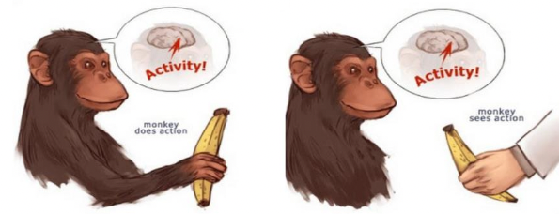

Mirror neurons help us learn from other people.

Mirror neurons are activated when observing an action regardless of if the action is meaningless of not ( no matter if there’s a goal)

Regarding the association between mirror neurons and empathy, it is debatable

Prosocial effects

* Behavior modeling can be used to help new employees learn communications, sales, and customer service skills
* People who exemplify nonviolent, helpful behavior can also prompt similar behavior in others

Antisocial effects

* Abusive parents tend to have more aggressive children
* Children who are lied to become more like to cheat and lie

The effect of TV for kids

The influence of Modern Families on children’s perception on homosexuals

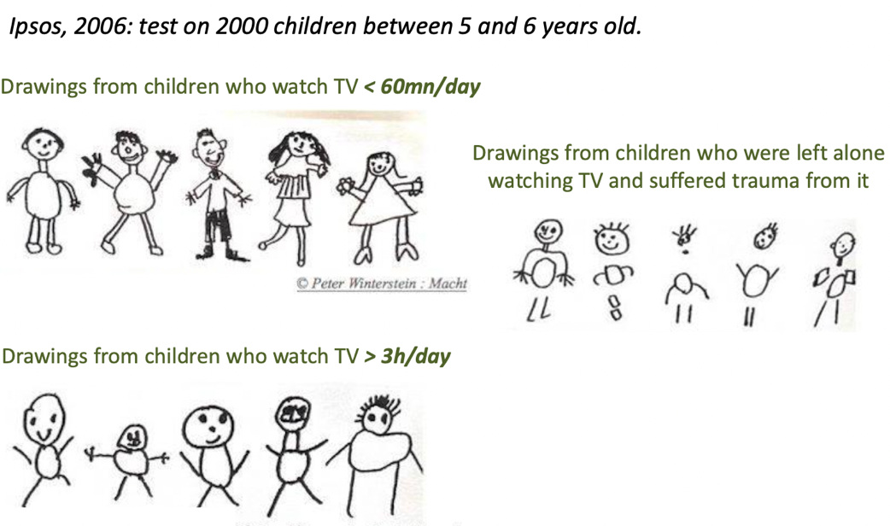

Play is presented in all species, and it is essential for learning. We learn and practice through playing.

A biopsychological approach

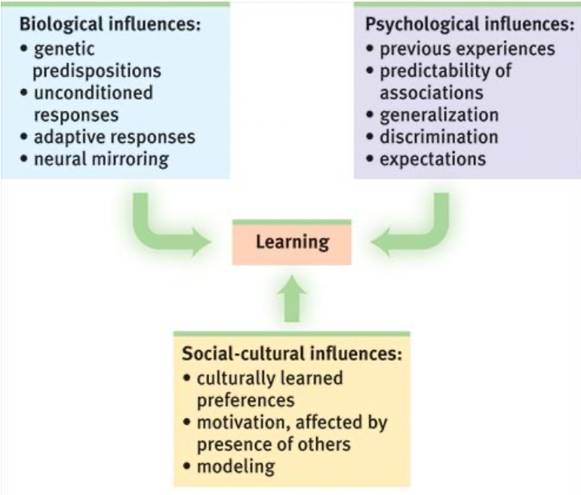

Free play: the action of playing should not be directed

There’s a HUGE decline in play in this century. It is correlated with rising percentage of mental illness.

(crash course video: classical and operant conditioning, Bobo doll experiment, mirror neurons)

Repetition, and learning by making mistakes are important in learning

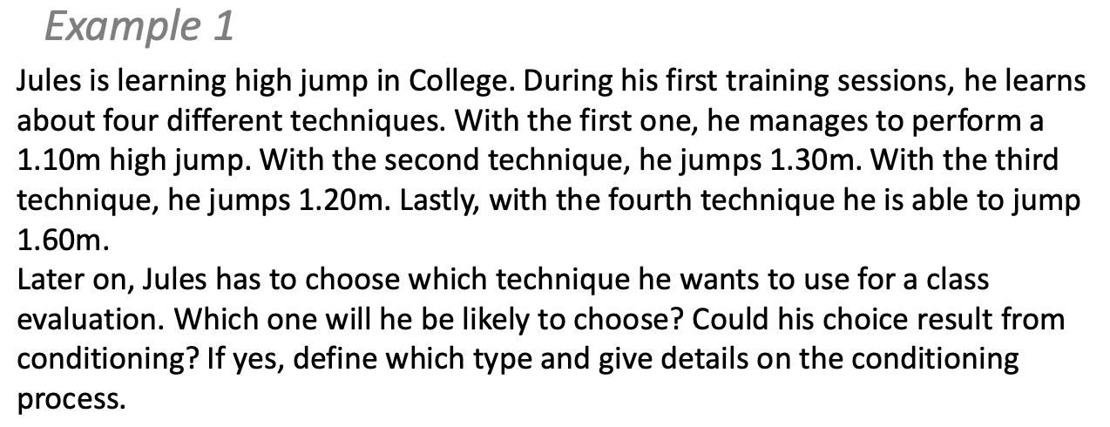

Operant conditioning (classical conditioning has physiological influence)

His behavior is increasing, its reinforcement.

He’s jumping higher to get a good mark

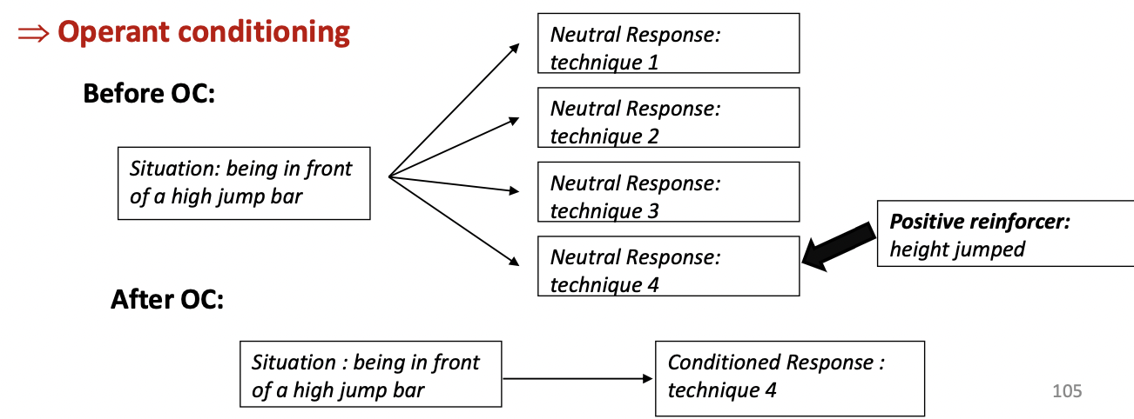

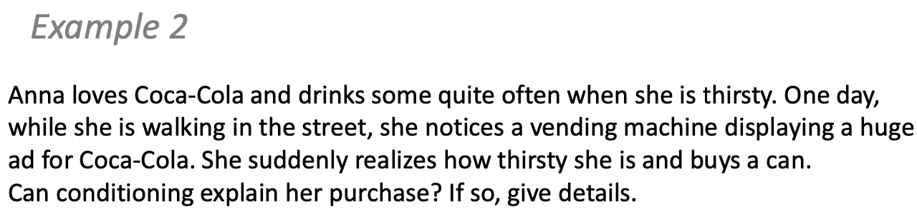

No

Classical conditioning (being thirsty)

